**Level 1: Presentation Notes**

1. Number systems used in Computer Science
   1. List the main features of the Decimal System  
        
      - Digits: 0,1,2,3,4,5,6,7,8,9

-Used for communicating with human users

* 1. List the main features of the Binary System (Base 2)

-Digits: 0,1 (On or Off)  
-Binary 10 == Decimal 2

-Used by internal CPU and Memory circuits

* 1. List the main features of the Octal System (Base 8)  
       
     -(Base 8)  
     -(No digits 8 & 9)

-Digits: 0,1,2,3,4,5,6,7

-Octal 10 == Decimal 8  
-Used by Computer Scientists for groupings of 3 binary digits

* 1. List the main features of the Hexadecimal System (Base 16)  
       
     -Digits: 0,1,2,3,4,5,6,7,8,9,A,B,C,D,E,F (Uses extra letters)

-Hex F == Decimal 15  
-Hex 10 == Decimal 16  
-Used by Computer Scientists for groupings of 4 binary digits

1. Compare and contrast the Decimal and Binary systems

|  |  |  |
| --- | --- | --- |
| **Criteria** | **Decimal System** | **Binary System** |
| Digits  Used | * 0,1,2,3,4,5,6,7,8,9 | * 0,1 (True, False) (+,-) |
| Addition Example | * 0+1 = 1 * 1+1 = 2 * 9+1 = 10 | * 0+1 = 1 * 1+1 = 10 * 11+1 = 100 |
| Powers of  Base | * 100 = 1 * 101 = 10 * 102 = 100 * Etc. | * 20 = 1 * 21 = 10 (or 2 decimal) * 22 = 100 (or 4 decimal) * Etc. |
| Value of 111 | * 111 = 102+101+100 * (100+10+1) | * 111 = 22+21+20 * (Decimal: 4+2+1 = 7) |

1. Convert the following binary numbers to decimal:  
   1. 11 binary = 2+1 = 3
   2. 101 binary = 4+1 = 5
   3. 1010 binary = 8+2 = 10
2. Convert the following decimal numbers to binary:  
   1. 6 decimal = 0110
   2. 13 decimal = 1101
3. Add the following binary numbers. (verify your answers using decimal)

|  |  |
| --- | --- |
| a)  0101 (decimal 5)  +0010 (decimal 2)  0111 7  4+2+1 | b)  0101 (decimal 5)  +1010 (decimal 10)  1111 15  8+4+2+1 |
| c)  0011 (decimal 3)  +0010 (decimal 2)  101 5  4+1 | d)  0110 (decimal 6)  +0011 (decimal 3)  1001 9  8+1 |

1. List the main features of the following Computer Memory Structures:
   1. Bit  
      -1 binary digit

-used for Boolean data type

-Building Block for All computer data and memory

* 1. Byte  
     -8 binary digits  
     -Largest value: 1111 1111 (28-1 = 255 decimal)

-Used for Char (character) data type

-26 lower case letters + 26 uppercase letters + 10 number symbols + punctuation marks + other stuff equal about 130 distinct characters

* 1. Word  
     -16 binary digits (2 bytes)

-Largest value: 1111 1111 1111 1111

(216-1 = 65,535 Decimal)

* 1. Integer Data Type (Short)  
     -Is 1 Word (16 bits)

-But must represent both Positive (+) and Negative (-)

-Range: +32767 to -32768  
-Larger or Smaller numbers require a different data type

* 1. Double Word

-32 binary digits (4 bytes or 2 words)

-Largest value: 232-1 = 4 billion approx)

Integer data type (Long)

-Provides much larger range than integer for Positive (+) and Negative (-) numbers

Double Word Memory Addressing

-Provides access to about 4 GB of memory max.

**Level 2: Research Questions**

1. The Intel 8085 microprocessor was a first generation processor that was used in many early game systems and personal computers. Google “8085 microprocessor architecture” to answer these questions.
   1. Year Introduced

The Intel 8085 microprocessor was introduced in 1976.

* 1. Size of data bus (in bits)

The data bus size is 8 bits.

* 1. Largest data number (in binary and decimal)

Binary: 0 to 1111 1111, decimal: 2^8 - 1 = 255.

* 1. Size of address bus (in bits)

The size of the address bus is 16 bits.

* 1. Largest memory address (in binary and decimal)

Binary: 0 to 1111 1111 1111 1111, decimal: 65 535.

1. The Intel 8086 microprocessor was the processor used in the first IBM PCs running the DOS operating system. Google “8086 microprocessor architecture” to answer these questions.
   1. Year Introduced

The Intel 8086 microprocessor was introduced in 1976.

* 1. Size of data bus (in bits)

The size of the data bus is 16 bits.

* 1. Largest data number (in decimal)

Decimal: 2^16 – 1 = 65 535.

* 1. Size of address bus (in bits)

The size of the address bus is 20 bits.

* 1. Largest memory address (in decimal)

Decimal: 2^20 – 1 = 1 048 575.

1. The Intel 80286 microprocessor a common processor used in IBM PCs running the Windows operating system. Google “80286 microprocessor architecture” to answer these questions.
   1. Year Introduced

The Intel 80286 microprocessor chip was introduced in 1982.

* 1. Size of data bus (in bits)

The size of the data bus is 16 bits.

* 1. Largest data number (in decimal)

Decimal: 2^16 – 1 = 65 535.

* 1. Size of address bus (in bits)

The size of the address bus is 24 bits.

* 1. Largest memory address (in decimal)

Decimal: 2^24 – 1 = 16 777 215.

1. The modern PCs run either a 32 bit or 64 bit Windows operating system. Google “32 vs 64 bit” to answer these questions.
   1. How do these systems differ in data capacity? (explain using bits)

Largest data capacity for the 32 bit Windows operating system: 2^32 – 1 = 4 294 967 295.

Largest data capacity for the 64 bit Windows operating system: 2^64 – 1 = 1.84 x 10 19.

* 1. How do these systems differ in memory capacity? (explain using bits)

Memory capacity for 32 bit: 2^32 – 1 = 4 294 967 295.

Memory capacity for 64 bit: 2^64 – 1 = 1.84 x 10 19.

* 1. How do these systems differ in hardware requirements?

Examples of 32 bit intel processors are the intel 80386, intel 80286, and the intel i960.

1. Research and explain how negative (-) numbers are represented using bits and how they are stored in computer memory.

Negative (-) numbers in bits begin with the number “1” instead of “0”. Negative numbers that are represented in bits can be in a “signed” format or an “unsigned” format.

1. Research and explain how floating point (decimal) numbers are represented using bits and how they are stored in computer memory.

Floating point (decimal) numbers are represented in base ten digits using bits. Decimal numbers contain an authorized significand as well as a base with an integer exponent. These floating point numbers are frequently shown on the authority of the IEEE 754 Standard.

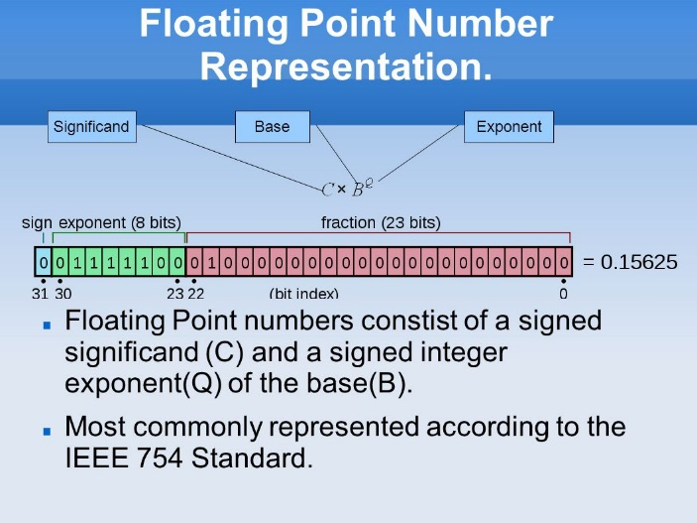

<https://www.google.com/search?q=floating+point+numbers+representation&safe=strict&rlz=1C1GGRV_enCA816CA817&source=lnms&tbm=isch&sa=X&ved=0ahUKEwi8q4mxibHfAhXFoIMKHR-rAr8Q_AUIDigB&biw=1920&bih=969#imgrc=-3mdb81VLlmEGM>:

**Level 3: Sample Program**

1. Modify the following sample Python program to print out the digits in:
   1. Binary
   2. Octal
   3. Hexadecimal

number = input("Enter a 4 digit decimal number:")

index = 0

for char in number :

index += 1

print("Digit ", index, " is : ", char)

**Modified Program For Binary:**

index = 0

index += 1

print("Digit ", index, " is : ", bin(10))

**Modified Program For Octal:**

index = 0

index += 1

print("Digit ", index, " is : ", oct(10))

**Modified Program For Hexadecimal:**

index = 0

index += 1

print("Digit ", index, " is : ", hex(10))

This is just a note for myself to remember:

DATA Size 8 BITS

In Binary 0 TO 1111 1111

In Decimal 0 TO 2N - 1 = 255